CSS стилове за хоризонтални линии

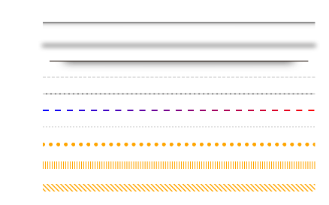

Съдържание
- Плътни линии
- Пунктирани линии
- Пунктирани линии
- Разни

Плътни линии
<hr class="hr-line">
<style>
.hr-line {
margin: 20px 0;
padding: 0;
height: 0;
border: none;
border-top: 1px solid #333;
}
</style>

Двойна линия
<hr class="hr-double">
<style>
.hr-double {
margin: 20px 0;
padding: 0;
height: 1px;
border: none;
border-top: 1px solid #333;
border-bottom: 1px solid #333;
}
</style>

Многоредов
<hr class="hr-multiline">
<style>
.hr-multiline {
margin: 20px 0;
padding: 0;
height: 20px;
border: none;
color: #333;
background-image: linear-gradient(currentColor, currentColor 33.33%, transparent 33.33%, transparent 100%);
background-size: 100% 3px;
}
</style>

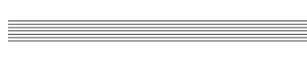

Двуцветна линия
<hr class="hr-two-color">
<style>
.hr-two-color {
margin: 20px 0;
padding: 0;
height: 0;
border: none;
border-top: 2px solid #ddd;
border-bottom: 2px solid #000;
}
</style>
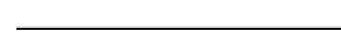

Трицветна линия
<hr class="hr-three-color">
<style>
.hr-three-color {
margin: 20px 0;
padding: 0;
height: 2px;
border: none;
border-top: 2px solid #ddd;
border-bottom: 2px solid #000;
background: orange;
}
</style>



Хоризонтален градиент
<hr class="hr-horizontal-gradient">
<style>
.hr-horizontal-gradient {
margin: 20px 0;
padding: 0;
height: 6px;
border: none;
background: linear-gradient(45deg, #333, #ddd);
}
</style>

Вертикален градиент
<hr class="hr-vertical-gradient">
<style>
.hr-vertical-gradient {
margin: 20px 0;
padding: 0;
height: 10px;
border: none;
background: linear-gradient(180deg, orange, blue);
}
</style>



Линия със сянка
<hr class="hr-shadow">
<style>
.hr-shadow {
margin: 20px 0;
padding: 0;
height: 10px;
border: none;
border-top: 1px solid #333;
box-shadow: 0 10px 10px -10px #8c8b8b inset;
}
</style>


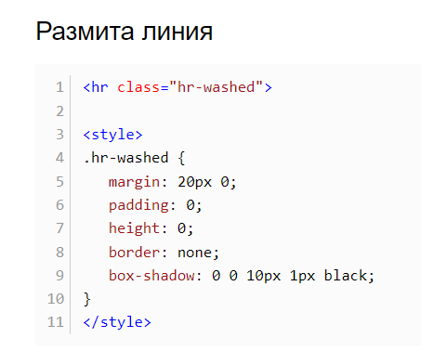



Линия "Рафт"
<hr class="hr-shelf">
<style>
.hr-shelf {
margin: -30px auto 10px;
padding: 0;
height: 50px;
border: none;
border-bottom: 1px solid #1f1209;
box-shadow: 0 20px 20px -20px #333;
width: 95%;
}
</style>

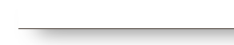

Пунктирани линии
<hr class="hr-dashed">
<style>
.hr-dashed {
margin: 20px 0;
padding: 0;
height: 0;
border: none;
border-top: 2px dashed #ddd;
}
</style>

Пунктирана линия с фон
<hr class="hr-dashed-bg">
<style>
.hr-dashed-bg {
margin: 20px 0;
padding: 0;
height: 0;
border: none;
border-top: 2px dashed #ddd;
background: #999;
}
</style>

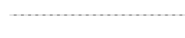

Линия от големи точки
<hr class="hr-circle">
<style>
.hr-circle {
margin: 20px 0;
padding: 0;
height: 0;
border: none;
border-width: 0 0 5px;
border-style: solid;
border-image: url('data:image/svg+xml,<svg xmlns="http://www.w3.org/2000/svg" viewBox="0 0 2 1" width="8" height="4"><circle fill="orange" cx="1" cy="0.5" r="0.5"></circle></svg>') 0 0 100% repeat;
background-position: 50%;
box-sizing: border-box;
color: orange;
}
</style>



Линии под ъгъл
<hr class="hr-sloping-lines">
<style>
.hr-sloping-lines {
margin: 20px 0;
padding: 0;
height: 10px;
border: none;
box-sizing: border-box;
background-position: 50%;
color: orange;
background-image: url('data:image/svg+xml,<svg xmlns="http://www.w3.org/2000/svg" width="3px" height="3px" viewBox="0 0 3 3" fill="orange"><polygon points="0,0.5 0,1.5 1.5,3 2.5,3"></polygon><polygon points="2.5,0 1.5,0 3,1.5 3,0.5"></polygon></svg>');
background-size: 6px 6px;
}
</style>



